**DSA Assignment – 17th June**

**Name – Karan Joshi**

**Roll No. – 23/11/EC/036**

**Leetcode Id – Karan_Joshi068048**

**Geeksforgeeks Id – wwwjoshikaran3424**

**Github Repo Link -** [**https://github.com/KaranJoshi101/urban-octo-robot/**](https://github.com/KaranJoshi101/urban-octo-robot/)

DSA-Section -

Question 1: Reverse digits

Platform: GeeksforGeeks

Problem Link: https://www.geeksforgeeks.org/problems/reverse-digits/1

Submission Screenshot:

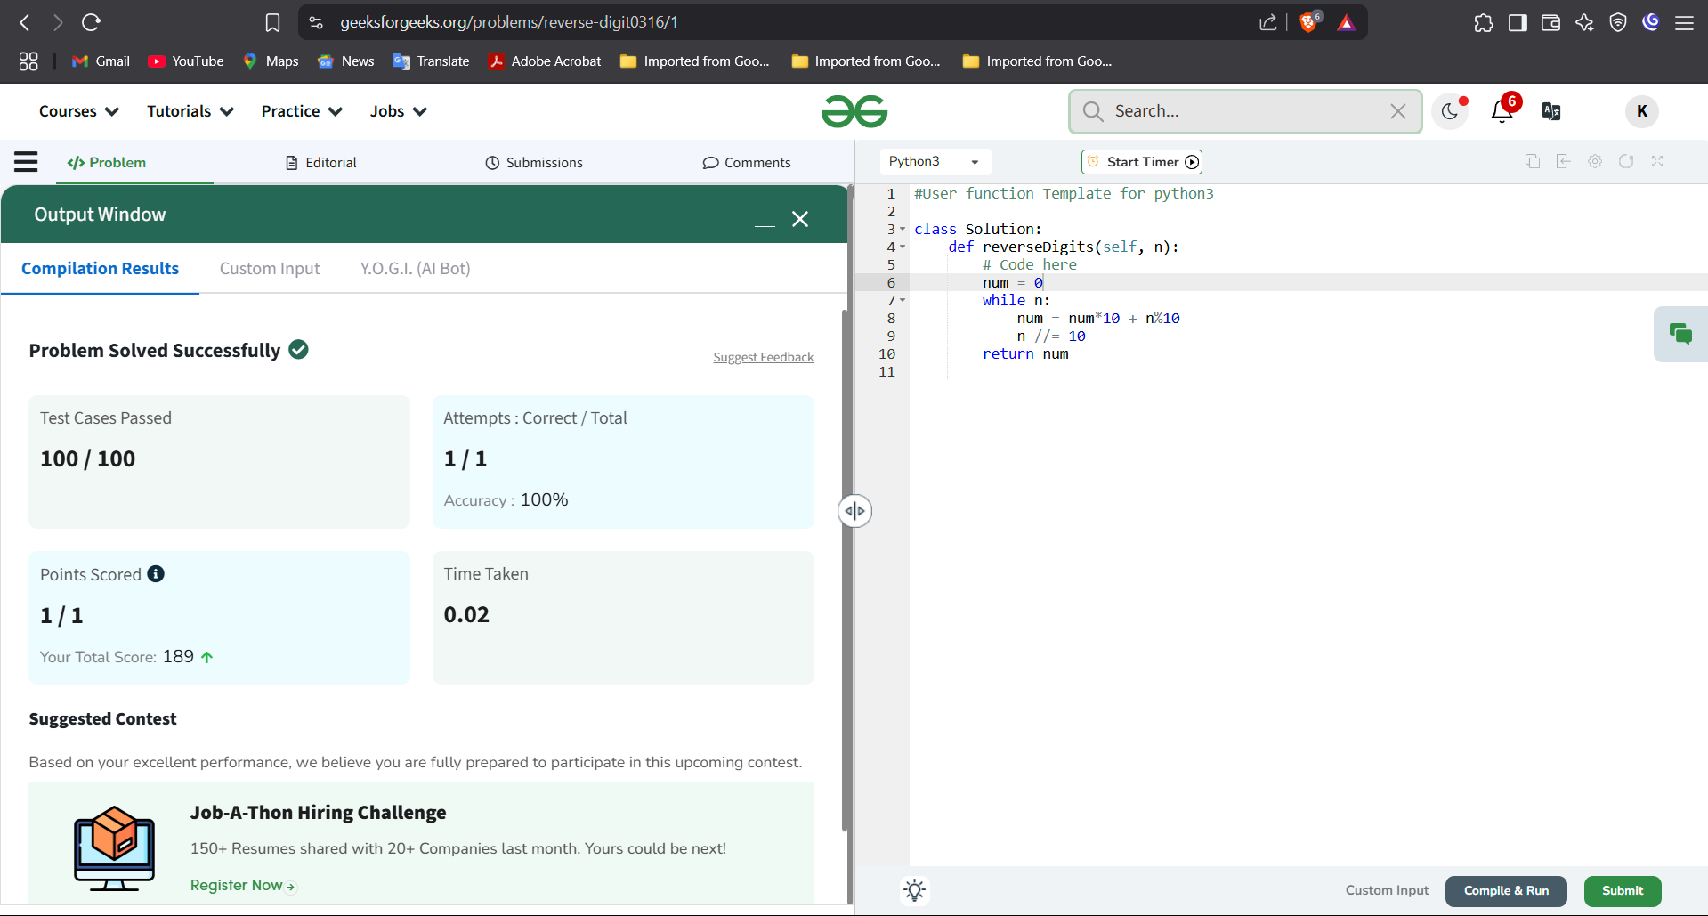

Question 2: Search Insert Position

Platform: LeetCode

Problem Link: https://leetcode.com/problems/search-insert-position/

Submission Screenshot:

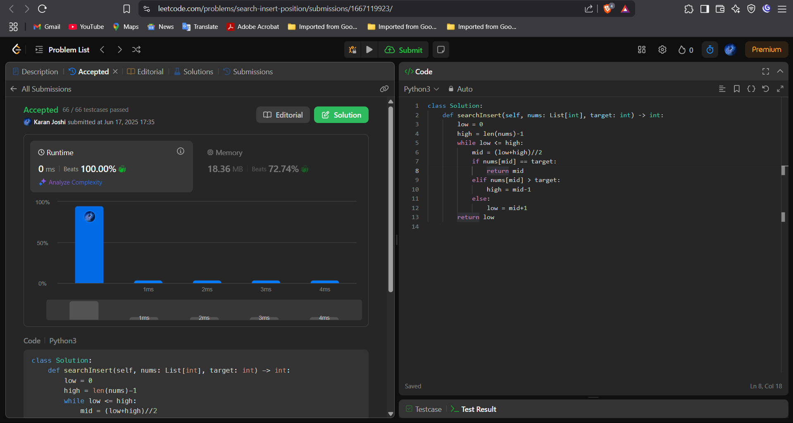

Question 3: Single Number

Platform: LeetCode

Problem Link: https://leetcode.com/problems/single-number/

Submission Screenshot:

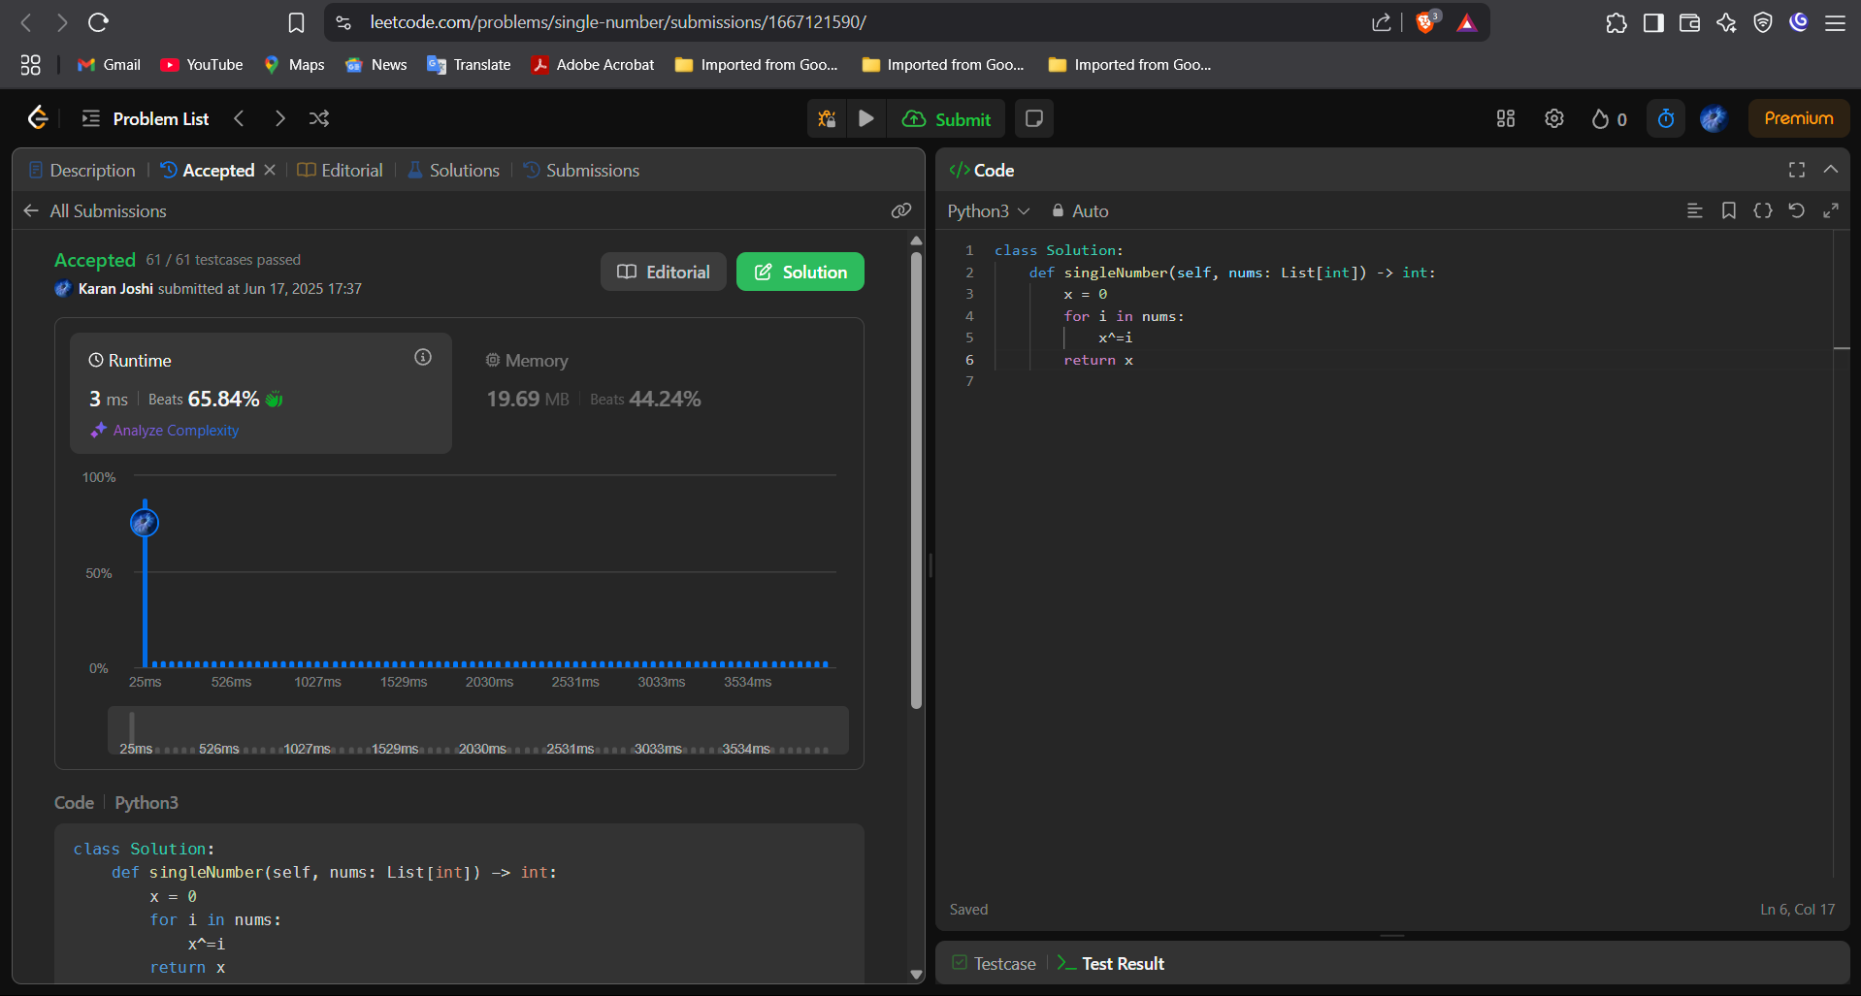



Question 4: Missing Number

Platform: LeetCode

Problem Link: https://leetcode.com/problems/missing-number/

Submission Screenshot:

